SIMATS ENGINEERING
ASSESSMENT TOOL 1

COURSE NAME: Artificial Intelligence COURSE CODE: CSA1704

COURSE OUTCOME COVERED

CO1: Apply AI basics such as intelligent agents and uninformed search methods to solve problems effectively. (BL3)

Assessment Tool Weightage: 50%

QUESTIONS: 5 Duration : 1 Hour
Total Marks:50

Annexure A

Analytical Problem Solving

Code of Conduct:

I MADHU BAVANA.B (192524103) (Name / Reg No) certify that this submission is my original work and that I have adhered to the guidelines specified for this assessment.
I understand that any violation of academic integrity rules will result in disciplinary action.

Signature of the student:
Madhu Bavana .B

Annexure A

Analytical Problem Solving

- Solve the Water Jug problem: you are given 2 jugs, a 4-gallon one and 3-gallon one. Neither has any measuring maker on it. There is a pump that can be used to fill the jugs with water. How can you get exactly 2 gallons of water into 4-gallon jug? Explicit assumptions: A jug can be filled from the pump, water can be poured out of a jug onto the ground, water can be poured from one jug to another and that there are no other measuring devices available.

- Find out how Mars Rover, analyse and explore the samples on Mars by answering the following questions.
- What are the percept’s for this agent?
- Characterize the operating environment.
- What are the actions the agent can take?
- How can one evaluate the performance of the agent?
- What sort of agent architecture do you think is most suitable for this agent? Why?

- Explore the search space using search strategies and formulate the problem components for the 8-Queens problem using the following information: Place 8 queens on a chessboard such that none of the queen’s attack any of the others. A configuration of 8 queens on the board as shown in the figure below, but this does not represent a solution as the queen in the first column is on the same diagonal as the queen in the last column.

- A customer wants to travel from the one location to another location using OLA Cab booking mobile application. The customer can select the any of the cab type as mini, micro, sedan, shared, prime and so on based on his comfort to reach the destination. Identify what type of problem-solving agent can be used and write the pseudocode for the above problem.

- A logistics company operates a delivery network where packages must be transported between warehouses at minimum cost. Each route between warehouses has an associated travel cost (fuel + time). The company wants to determine the least-cost path from the starting warehouse S to the destination warehouse G using the Uniform Cost Search (UCS) algorithm.

The delivery network is represented as a weighted graph:
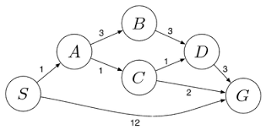

RUBRICS FOR CALCULATION:
Criteria | Weightage | Level 4 (Exemplary) | Level 3 (Proficient) | Level 2 (Developing) | Level 1 (Beginning)
Problem Understanding | 20% | Clearly interprets problem, identifies all parameters and requirements accurately | Understands problem with minor gaps | Partial understanding; misses key elements | Misinterprets or unable to understand problem
Method Selection | 20% | Selects most appropriate method/formula with strong justification | Selects correct method with minor errors | Inappropriate or partially correct method | Unable to select method
Solution Process | 25% | Logical, systematic steps with correct approach throughout | Mostly correct steps with minor mistakes | Disorganized steps; multiple errors | No clear process
Accuracy of Calculation | 20% | All calculations accurate; correct final answer | Minor calculation errors | Frequent errors; incorrect final answer | No valid calculations
Interpretation of Results | 15% | Clearly interprets results with units and engineering relevance | Basic interpretation with minor omissions | Limited or unclear interpretation | No interpretation
Problem Understanding | 20% | Clearly interprets problem, identifies all parameters and requirements accurately | Understands problem with minor gaps | Partial understanding; misses key elements | Misinterprets or unable to understand problem

1. Solve the Water Jug Problem: You are given two jugs, one with a capacity of 4 gallons and the other with a capacity of 3 gallons. Neither jug has any measuring marks. A pump can be used to fill the jugs with water. Water can be poured from one jug to another or emptied onto the ground. There are no other measuring devices available.

PROBLEM STATEMENT
Two jugs with capacities 4 gallons and 3 gallons are available. Neither jug has any measurement markings. The allowed operations are:
- Fill a jug completely from the pump.
- Empty a jug onto the ground.
- Pour water from one jug to another until one jug becomes full or the other becomes empty.
The objective is to obtain exactly 2 gallons of water in the 4-gallon jug.

Given
- Jug A = 4 gallons
- Jug B = 3 gallons
- Initial State = (0,0)
- Goal State = (2,x), where x = 0–3

Assumptions
- Unlimited water supply.
- Water can be discarded.
- Water can be transferred between jugs.
- No measuring scale or additional container is available.

METHOD SELECTION

Method Used
The problem is solved using the State Space Search approach.

Justification
- Every state represents the amount of water in both jugs.
- Each operation (Fill, Empty, Pour) generates a new state.
- The search continues until the goal state is reached.
- This method guarantees a systematic and correct solution.

SOLUTION PROCESS

State Representation
State = (Water in 4-gallon jug, Water in 3-gallon jug)

Initial State
(0,0)

Goal State
(2,0)

Step-by-Step Solution
Step | Action | State (4G,3G)
1 | Start | (0,0)
2 | Fill the 3-gallon jug | (0,3)
3 | Pour 3G into 4G | (3,0)
4 | Fill the 3-gallon jug again | (3,3)
5 | Pour from 3G to 4G until 4G is full | (4,2)
6 | Empty the 4-gallon jug | (0,2)
7 | Pour the remaining 2 gallons into the 4-gallon jug | (2,0) ✓

ACCURACY OF CALCULATION
The amount of water after each operation is calculated correctly.
Operation | 4G Jug | 3G Jug
Initial | 0 | 0
Fill 3G | 0 | 3
Pour to 4G | 3 | 0
Fill 3G | 3 | 3
Pour to 4G | 4 | 2
Empty 4G | 0 | 2
Pour to 4G | 2 | 0
Final State = (2,0)
The required 2 gallons are successfully obtained in the 4-gallon jug.

INTERPRETATION OF RESULTS
The Water Jug problem has been successfully solved using the State Space Search method. Starting from the initial state (0,0), valid operations (Fill, Pour, and Empty) were applied to generate successive states until the goal state (2,0) was reached. This demonstrates that search-based problem-solving can systematically find a valid solution by exploring the state space. Therefore, the objective of measuring exactly 2 gallons in the 4-gallon jug is achieved.

(A) PEAS DESCRIPTION

PEAS Component | Description
Performance Measure | Successfully collect scientific samples, avoid obstacles, conserve battery power, navigate safely, communicate with mission control, and complete the mission efficiently.
Environment | Mars surface containing rocks, sand, craters, hills, dust storms, varying temperatures, and communication delays.
Actuators | Wheels, robotic arm, drill, sample collection mechanism, camera controller, communication antenna, solar panel controller.
Sensors | Cameras, proximity sensors, GPS/position sensors, temperature sensors, battery sensors, accelerometer, gyroscope, environmental sensors.

(b) ENVIRONMENT Type
The Mars Rover operates in the following environment:
- Partially Observable: The rover cannot observe the entire Mars environment at once because obstacles and terrain may not be visible until it moves closer.
- Stochastic: Dust storms, wheel slippage, and unexpected obstacles make the environment unpredictable.
- Sequential: Each action affects future actions and mission success.
- Dynamic: Environmental conditions such as weather, lighting, and terrain can change over time.
- Continuous: Movement, distance, speed, and battery level change continuously.
- Single Agent: The rover performs its mission independently without competing agents.

(C) SUITABLE INTELLIGENT AGENT

Learning Agent
A Learning Agent is the most suitable for the Mars Rover because it can improve its performance based on experience.

Justification
- Learns from previous navigation experiences.
- Adapts to unknown terrain and obstacles.
- Optimizes battery usage.
- Improves route planning over time.
- Increases mission efficiency and safety.
(D) ARCHITECTURE OF MARS ROVER INTELLIGENT AGENT
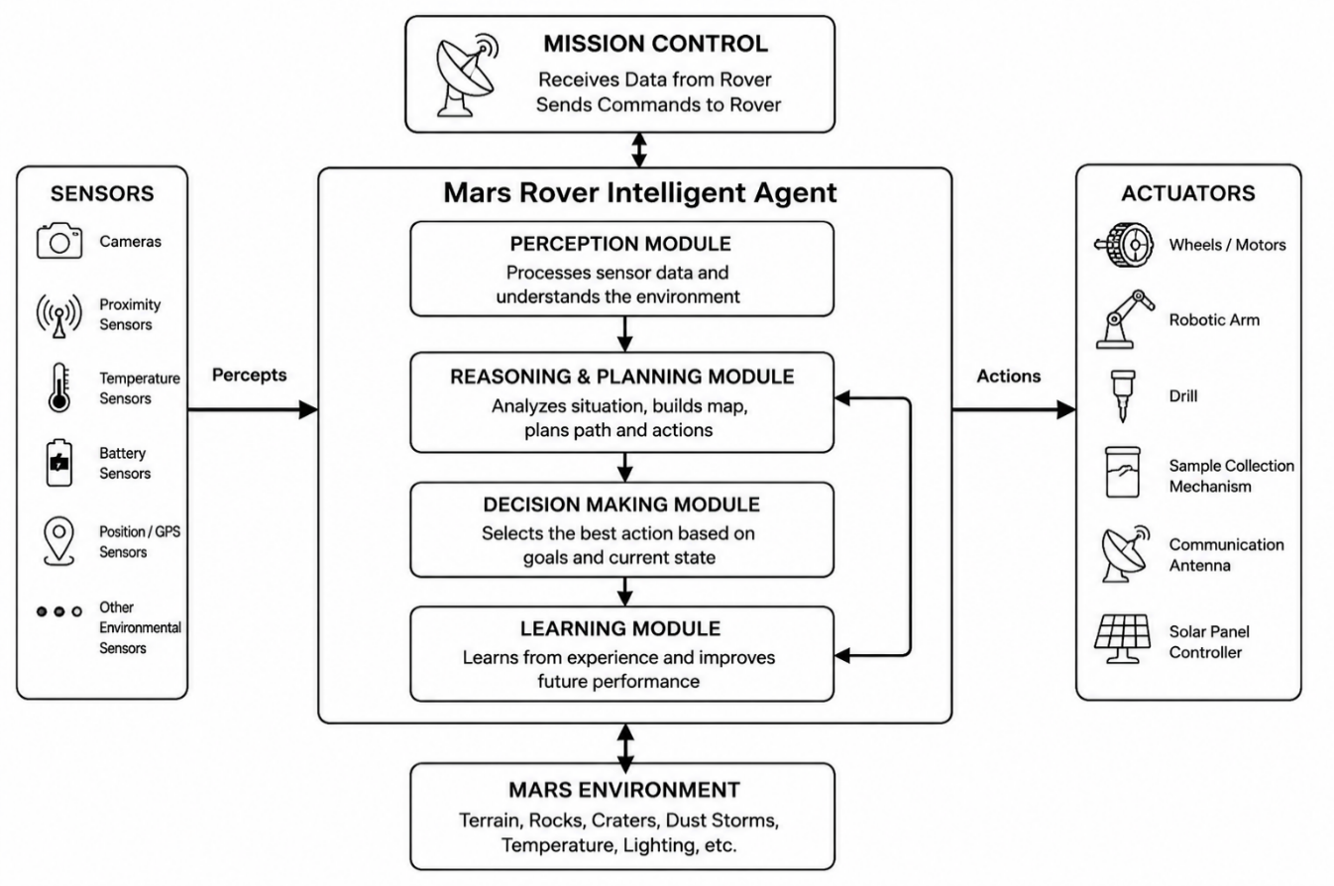

(E) WORKING OF THE MARS ROVER INTELLIGENT AGENT

Perception
The rover collects information from its cameras, proximity sensors, temperature sensors, battery monitor, and other onboard sensors to understand its surroundings.

Reasoning
The intelligent agent analyzes the sensor data to identify obstacles, determine safe paths, estimate battery usage, and prioritize scientific tasks.

Planning
Based on its analysis, the rover plans the safest and most efficient route, schedules sample collection, manages energy consumption, and determines when to communicate with mission control.

Action
The rover executes the planned actions by moving through the terrain, avoiding obstacles, collecting rock or soil samples, recharging using solar panels when necessary, and transmitting scientific data back to mission control.

CONCLUSION
The Mars Rover is best modeled as a Learning Agent operating in a partially observable, stochastic, sequential, dynamic, continuous, and single-agent environment. By continuously perceiving, reasoning, planning, and acting, it can safely navigate Mars, collect valuable scientific data, and successfully accomplish its mission.

3.Explore the search space using search strategies and formulate the problem components for the 8-Queens Problem .Place 8 queens on an 8 × 8 chessboard such that no two queens attack each other. A queen can attack another queen if they are in the same row, column, or diagonal .The given configuration of 8 queens on the chessboard (shown in the figure) is not a solution, because the queen in the first column is on the same diagonal as the queen in the last column.

(A) PROBLEM FORMULATION
The 8-Queens Problem is a classic search problem in Artificial Intelligence. The objective is to place 8 queens on an 8 × 8 chessboard such that no two queens attack each other. A queen can attack horizontally, vertically, and diagonally. The given configuration is not a solution because the queen in the first column attacks the queen in the last column diagonally.

Problem Components

1. Initial State
An empty 8 × 8 chessboard with no queens placed.

2. State Space
All possible arrangements of placing queens on the chessboard, one queen per column.

3. Actions (Operators)
- Place a queen in any safe row of the next column.
- Move a queen if conflicts occur (during local search).

4. Transition Model
Each action generates a new board configuration by placing a queen in the next column while checking for conflicts.

5. Goal Test
A solution is reached when:
- Exactly 8 queens are placed.
- No two queens share the same row, column, or diagonal.

6. Path Cost
Each move has an equal cost (1). The objective is to find any valid solution rather than minimizing cost.

Search Strategy
The Backtracking Search Algorithm is commonly used because it places queens one column at a time and backtracks whenever a conflict occurs. This avoids exploring invalid board configurations and efficiently finds a valid solution.

State Representation
A state is represented as:
(R₁, R₂, R₃, R₄, R₅, R₆, R₇, R₈)
where Rᵢ represents the row position of the queen in the i-th column.
Example:
(1, 5, 8, 6, 3, 7, 2, 4)
This means:
- Column 1 → Row 1
- Column 2 → Row 5
- Column 3 → Row 8
- Column 4 → Row 6
- Column 5 → Row 3
- Column 6 → Row 7
- Column 7 → Row 2
- Column 8 → Row 4

CONCLUSION
The 8-Queens Problem is formulated as a state-space search problem. Using the Backtracking Search strategy, queens are placed systematically while checking row, column, and diagonal constraints until a valid arrangement of eight non-attacking queens is obtained.

4. A customer wants to travel from one location to another using the OLA Cab Booking mobile application. The customer can select the cab type, such as Mini, Micro, Sedan, Shared, Prime, and others, based on the travel distance, fare, and personal preferences .Identify the type of problem-solving agent that can be used for this scenario and write the pseudocode for the above problem

PROBLEM STATEMENT
A customer wants to travel from one location to another using the OLA Cab Booking mobile application. The customer can choose a cab type such as Mini, Micro, Sedan, Shared, Prime, etc., based on travel distance, fare, and personal preferences. The objective is to select the most suitable cab for the customer's journey.

Given
- Source location
- Destination location
- Cab types (Mini, Micro, Sedan, Shared, Prime)
- Estimated fare
- Distance
- Customer preferences

Assumptions
- GPS is available to identify locations.
- All cab types are available.
- Fare is calculated automatically.
- The user has internet connectivity.

METHOD SELECTION

Type of Problem-Solving Agent
Goal-Based Agent

Justification
A Goal-Based Agent is the most suitable because it selects the cab that best satisfies the user's goal of reaching the destination while considering factors such as fare, distance, availability, and comfort.

Solution Process

Algorithm
- Start.
- Enter the source and destination locations.
- Calculate the travel distance and estimated fare.
- Display the available cab types (Mini, Micro, Sedan, Shared, Prime).
- Select the cab that best matches the customer's preferences.
- Confirm the booking and assign the nearest available driver.
- Display the booking details and end the process.

PSEUDOCODE
BEGIN

Input Source
Input Destination

Calculate Distance
Calculate Estimated Fare

Display Available Cab Types

Input Customer Choice

IF Selected Cab is Available THEN
Book the Cab
Assign Nearest Driver
Display Booking Confirmation
ELSE
Display "Selected Cab Not Available"
Suggest Another Cab Type
ENDIF

END

Accuracy of Solution
- Source and destination are correctly entered.
- Distance and fare are calculated.
- Available cab types are displayed.
- The selected cab is checked for availability.
- Booking is confirmed if a cab is available.
- Alternative cab is suggested if unavailable.

INTERPRETATION OF RESULTS
The Goal-Based Agent successfully selects the most appropriate cab based on the customer's travel requirements. It considers the destination, distance, fare, cab availability, and user preferences before making a decision. If the selected cab is unavailable, the agent recommends another suitable option, ensuring efficient and reliable cab booking.
5. A logistics company operates a delivery network where packages must be transported between warehouses at minimum cost. Each route between warehouses has an associated travel cost (fuel + time). The company wants to determine the least-cost path from the starting warehouse S to the destination warehouse G using the Uniform Cost Search (UCS) algorithm.
The delivery network is represented as a weighted graph

PROBLEM STATEMENT
A logistics company operates a delivery network where packages must be transported between warehouses at the minimum cost. Each route between warehouses has an associated travel cost (fuel + time). Using the given weighted graph, determine the least-cost path from the starting warehouse S to the destination warehouse G using the Uniform Cost Search (UCS) algorithm.

Given
- Start Node = S
- Goal Node = G
- Weighted graph as given in the question.
- All edge costs are non-negative.

Assumptions
- The graph is connected.
- Edge costs represent travel cost.
- UCS expands the node with the lowest cumulative path cost.

Method Selection (20%)

Method Used
Uniform Cost Search (UCS)

Justification
Uniform Cost Search expands the node with the lowest cumulative cost from the start node. It guarantees the optimal solution when all edge costs are positive or non-negative.

Solution Process (25%)

Step 1: Initial State
Priority Queue = {(S, 0)}

Step 2: Node Expansion
Step | Expanded Node | Path | Cost
1 | S | S | 0
2 | A | S → A | 1
3 | C | S → A → C | 2
4 | B | S → A → B | 4
5 | G | S → A → C → G | 4
The goal node G is reached with the minimum cumulative cost of 4.

ACCURACY OF CALCULATION

Cost Calculation
Optimal Path:
S → A → C → G
- S → A = 1
- A → C = 1
- C → G = 2
Total Cost = 1 + 1 + 2 = 4

Other Possible Paths
Path | Cost
S → G | 12
S → A → B → D → G | 1 + 3 + 3 + 3 = 10
S → A → C → D → G | 1 + 1 + 1 + 3 = 6
S → A → C → G | 1 + 1 + 2 = 4 ✅
Since 4 is the smallest cost, UCS selects this path.

INTERPRETATION OF RESULTS
The Uniform Cost Search algorithm successfully finds the least-cost path from the start node S to the goal node G by expanding nodes in order of increasing cumulative cost. Among all possible routes, the path S → A → C → G has the minimum total cost of 4. Therefore, UCS guarantees the optimal solution for the given weighted graph.

